**流浪NK：实现文档**

团队成员

姜天嘉

闫钊辉

张继盛

王天鹏

# 项目任务分配：

姜天嘉：实现了前台后台界面的设计，实现了前台数据分析板块，实现了后台作业提交界面，权限管理界面，成员简介管理界面

闫钊辉：实现了前台全局概况板块

王天鹏：实现了前台博客界面板块

张继盛：实现了前台新闻界面板块

# Github提交记录

commit 66ee1fe231cc363dc5a88a758d84879ffb882545 (HEAD -> master, origin/master)

Author: G2 OptJiang20 <2499184084@qq.com>

Date: Sat Feb 11 01:52:41 2023 +0800

add vendor

commit 1bcf7817b50bdf4bfe64b3983afde8a3a7f8f9dd

Author: G2 OptJiang20 <2499184084@qq.com>

Date: Fri Feb 10 17:14:55 2023 +0800

final project

commit 481ff7064585550ccad7e07d9c2d3aba37efa80f

Author: unknown <1341210299@qq.com>

Date: Fri Feb 10 15:06:56 2023 +0800

115

commit 13dd2bd2dd7daecd6689d06e289cafef2cc295c3

Merge: 79788c7 c13e4cb

Author: 王天鹏 <2664004187@qq.com>

Date: Fri Feb 10 07:21:24 2023 +0800

Merge branch 'master' of https://github.com/JiangSio/Internet-Database-Project

拉取远程分支。

commit 79788c77f21a03bc03e1482d5b2683c95acdb860

Author: 王天鹏 <2664004187@qq.com>

Date: Fri Feb 10 07:19:06 2023 +0800

”完善新闻展示模块“

commit c13e4cb69647dbfc071f9ba1d0281aad1271e27e

Author: G2 OptJiang20 <2499184084@qq.com>

Date: Thu Feb 9 00:05:27 2023 +0800

jtj+zjs

commit dd70b285ac8036fe4cd045e3ef1c4fcbc4608936

Author: unknown <1341210299@qq.com>

Date: Wed Feb 8 19:57:04 2023 +0800

init

commit 10c4feb323339469ed5388972c1ff8b9d3f921c8

Author: 2012615 <2536196890@qq.com>

Date: Wed Feb 8 15:24:27 2023 +0800

yii2022 1.0

commit c560aa48b618fd472b2c90a38f92ded92a57e270

Author: 2012615 <2536196890@qq.com>

Date: Wed Feb 8 15:21:36 2023 +0800

2

commit 82de1ff2b6a29986c9f2fb3a5a3977b12d0cb469

Author: 2012615 <2536196890@qq.com>

Date: Wed Feb 8 15:21:08 2023 +0800

1

commit be3dd7f781b208405bde8f116d2d2b5ba0f70fa4

Merge: 615f977 46c0adb

Author: 2012615 <2536196890@qq.com>

Date: Wed Feb 8 15:20:22 2023 +0800

Merge branch 'master' of https://github.com/JiangSio/Internet-Database-Project

commit 615f977adfd2a01354aef1cc26a9ae4b9a76bcf9

Author: 2012615 <2536196890@qq.com>

Date: Wed Feb 8 15:16:21 2023 +0800

yii2.0 advanced 1.0

commit 46c0adb369919e28e2cbbe7ea3a56321ea9f9617

Author: G2 OptJiang20 <2499184084@qq.com>

Date: Mon Feb 6 15:35:27 2023 +0800

前台后台首页添加

commit 8201e41b3151a1e11542a1f5375b774f9a955708

Author: G2 OptJiang20 <2499184084@qq.com>

Date: Mon Feb 6 15:13:16 2023 +0800

前端后台首页设计

commit 1e202b366a6b80901584595bf15aa1956faf2a94

Author: 2012615 <2536196890@qq.com>

Date: Sat Feb 4 16:51:10 2023 +0800

yii2更新模板

commit 54e2d8fc03850cc9a72cbb63b064a2890d560291

Merge: e48d637 793efcd

Author: 2012615 <2536196890@qq.com>

Date: Sat Feb 4 16:43:03 2023 +0800

Merge branch 'master' of https://github.com/JiangSio/Internet-Database-Project

commit e48d637bd49bfbac5547bac069fa75426485374a

Author: 2012615 <2536196890@qq.com>

Date: Sat Feb 4 16:40:39 2023 +0800

2

commit b5e9beeb36d7ae561e5083d9fe4d61b249f3b4f0

Author: 2012615 <2536196890@qq.com>

Date: Sat Feb 4 16:37:04 2023 +0800

更新模板yii2

commit 793efcd4147ed0a67a6696105cfb5d3571a9876f

Author: G2 OptJiang20 <2499184084@qq.com>

Date: Wed Feb 1 23:54:30 2023 +0800

中国与俄乌外贸分析

commit ee6d6d8619edd5a4f03fc0474c87b9c160500516

Author: G2 OptJiang20 <2499184084@qq.com>

Date: Wed Feb 1 21:04:16 2023 +0800

油价分析界面

commit 2c371df00ecfa852e0fbbd447d5007960374df25

Author: 2012615 <2536196890@qq.com>

Date: Tue Jan 31 17:34:56 2023 +0800

yii2

commit 9297b375f1ba8507882dd1e2bb9b144c051dbc8a

Author: 2012615 <2536196890@qq.com>

Date: Tue Jan 31 15:47:27 2023 +0800

9

commit 56b1ab843dcfa843fce65d180c737929e42f491d

Author: 2012615 <2536196890@qq.com>

Date: Tue Jan 31 15:46:48 2023 +0800

8

commit d62cb975b3757e8238daec63612d1431bfac4df4

Author: 2012615 <2536196890@qq.com>

Date: Tue Jan 31 15:46:23 2023 +0800

7

commit 66cf524d8bb18f7c54c461ae81d52a9101ae04d8

Author: 2012615 <2536196890@qq.com>

Date: Tue Jan 31 15:41:48 2023 +0800

担当

commit a8900c2f76e97601c80bbffa6d4628af21706caa

Author: 2012615 <2536196890@qq.com>

Date: Tue Jan 31 15:40:19 2023 +0800

6

commit fb3f0b196280970b54a09d234bc44386225bcf48

Author: 2012615 <2536196890@qq.com>

Date: Tue Jan 31 15:39:45 2023 +0800

5

commit 485e6f715279541cea3c760bfc846cb56f5200de

Author: 2012615 <2536196890@qq.com>

Date: Tue Jan 31 15:39:02 2023 +0800

4

commit bc35fabd33822c348e14a7b468c9faae958308e3

Author: 2012615 <2536196890@qq.com>

Date: Tue Jan 31 15:37:58 2023 +0800

3

commit eb873cacff41ff9eb7a905d3929aa82a67b8def6

Author: 2012615 <2536196890@qq.com>

Date: Tue Jan 31 15:34:14 2023 +0800

2

commit 2be5aef4d5dafc94580f2781b7fa61dbfc183e0a

Author: 2012615 <2536196890@qq.com>

Date: Tue Jan 31 15:33:24 2023 +0800

1

commit 3849719f8c4d4e58e489ae30690eaa70a00d979c

Author: 2012615 <2536196890@qq.com>

Date: Mon Jan 30 18:50:18 2023 +0800

2

commit cab9fa1aa6c3c194fee8197e95bc5461bd4f091b

Author: 2012615 <2536196890@qq.com>

Date: Mon Jan 30 18:46:47 2023 +0800

1

commit 05921f957b38afb8c9c5e27312c8f2016cd68ff3

Author: 2012615 <2536196890@qq.com>

Date: Mon Jan 30 18:41:46 2023 +0800

1

commit 8051de209e2ba46f19f82abd7263681948c8524e

Author: 2012615 <2536196890@qq.com>

Date: Mon Jan 30 18:38:26 2023 +0800

1

commit 45a2b1ed357459685657ce55ad3548d5c8886a92

Author: 王天鹏 <2664004187@qq.com>

Date: Mon Jan 30 14:59:37 2023 +0800

王天鹏的第一次提交，配置yii2框架完成。

commit a87ae8dced3ea3833320f777a88a60878ec4964b

Author: G2 OptJiang20 <2499184084@qq.com>

Date: Mon Jan 30 14:39:37 2023 +0800

init yii2 advanced

commit e58123fd3ee24486cb6e25c39fe2a10325f6fab6

Author: G2 OptJiang20 <2499184084@qq.com>

Date: Sat Jan 28 21:02:41 2023 +0800

init workspace

commit a091550367bfd0b420404ca3b22d46d3769bcd66 (origin/main)

Author: JiangSio <102448598+JiangSio@users.noreply.github.com>

Date: Sat Jan 28 20:50:37 2023 +0800

Initial commit

# 实现文档@王天鹏

**实现文档**

——王天鹏 2013013

## 新闻列表页面

### 页面展示



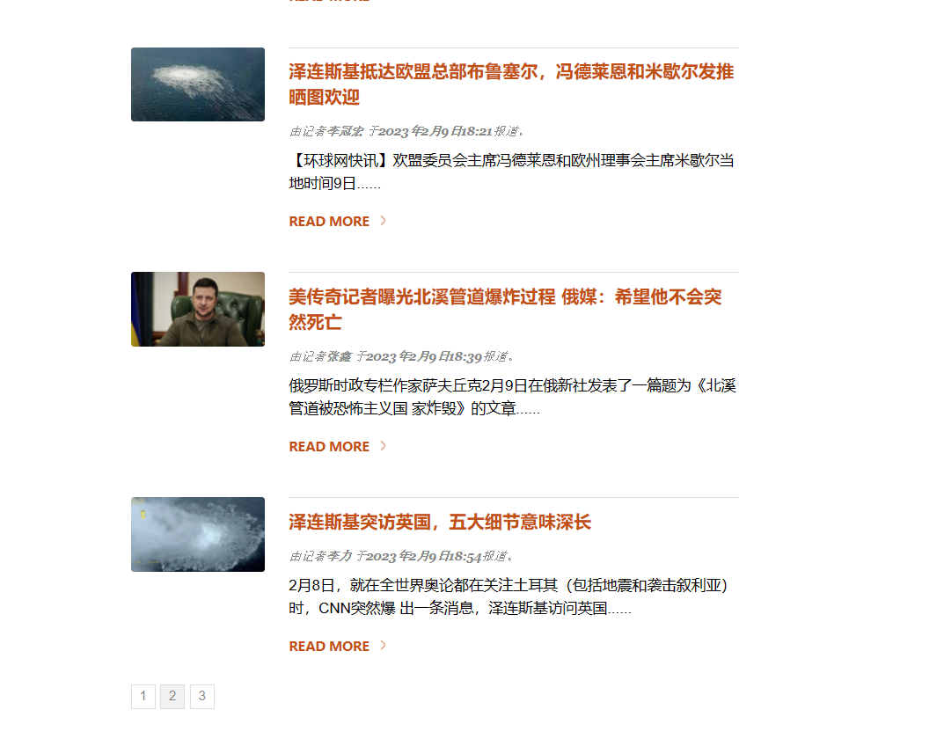

### 功能实现

1.展示图片、新闻以及摘要

2.更新新闻的报道日期、时间、报道人

3.通过read more实现新闻详情页跳转

4.实现分页展示功能

### 代码展示

涉及表author、news。

视图层

<section class="top-image" style="background:url('css/images/1.jpg') no-repeat top center;">  
 <h1>俄乌战争最新局势报道</h1>  
</section>  
  
<section id="bottom">  
 <section class="shell">  
  
 <section id="content" class="news-feed two_third">  
  
 <div class="one_fourth">  
 <img src="//d.ifengimg.com/w144_h80_q70/x0.ifengimg.com/ucms/2023_06/5A0724216D93B6D25539DD8531B4F99CFBCF7466_size56_w630_h354.jpg" width="100%" />  
 </div>  
  
 <div class="three_fourth last">  
 <h4 class="title"><a href="./index.php?r=article/index0#">  
 <?php echo $title[0]['title']; ?>  
 </a></h4>  
  
 <div class="post-meta">  
 由记者<strong><?php echo $authorName[0]['authorName']; ?></a></strong> 于<strong><?php echo $doneDate[0]['doneDate']; ?></strong><strong><?php echo $doneTime[0]['doneTime']; ?></strong>报道。  
 </div>  
  
 <p><?php echo $abstract[0]['abstract']; ?></p>  
  
 <p><a href="./index.php?r=article/index0#" class="continue">Read More</a></p>  
 </div>  
  
 <div class="cl"></div>  
  
 <div class="one_fourth">  
 <img src="//d.ifengimg.com/w144_h80_q70/x0.ifengimg.com/ucms/2023_06/2B0DFB01FF77BCE4199C4489FD89D17ED09121E1_size60_w975_h549.jpg" width="100%" />  
 </div>  
  
 <div class="three_fourth last">  
 <h4 class="title"><a href="./index.php?r=article/index1#">  
 <?php echo $title[1]['title']; ?>  
 </a></h4>  
  
 <div class="post-meta">  
 由记者<strong><?php echo $authorName[1]['authorName']; ?></a></strong> 于<strong><?php echo $doneDate[1]['doneDate']; ?></strong><strong><?php echo $doneTime[1]['doneTime']; ?></strong>报道。  
 </div>  
  
 <p><?php echo $abstract[1]['abstract']; ?></p>  
  
 <p><a href="./index.php?r=article/index1#" class="continue">Read More</a></p>  
 </div>  
  
 <div class="cl"></div>  
  
 <div class="one_fourth">  
 <img src="//d.ifengimg.com/w144_h80_q70/x0.ifengimg.com/ucms/2023_06/BCEF1C1B4F2B8D1254F3431ED56C008EC193F1D4_size22_w667_h375.jpg" width="100%" />  
 </div>  
  
 <div class="three_fourth last">  
 <h4 class="title"><a href="./index.php?r=article/index2#">  
 <?php echo $title[2]['title']; ?>  
 </a></h4>  
  
 <div class="post-meta">  
 由记者<strong><?php echo $authorName[2]['authorName']; ?></a></strong> 于<strong><?php echo $doneDate[2]['doneDate']; ?></strong><strong><?php echo $doneTime[2]['doneTime']; ?></strong>报道。  
 </div>  
  
 <p><?php echo $abstract[2]['abstract']; ?></p>  
  
 <p><a href="./index.php?r=article/index2#" class="continue">Read More</a></p>  
 </div>  
  
 <div class="cl"></div>  
  
 <div class="one_fourth">  
 <img src="//d.ifengimg.com/w144_h80_q70/x0.ifengimg.com/ucms/2023_06/A1E5DA1E816B4D58C3C1CB1CE2E92225FF1A3668_size84_w640_h360.jpg" width="100%" />  
 </div>  
  
 <div class="three_fourth last">  
 <h4 class="title"><a href="./index.php?r=article/index3#">  
 <?php echo $title[3]['title']; ?>  
 </a></h4>  
  
 <div class="post-meta">  
 由记者<strong><?php echo $authorName[3]['authorName']; ?></a></strong> 于<strong><?php echo $doneDate[3]['doneDate']; ?></strong><strong><?php echo $doneTime[3]['doneTime']; ?></strong>报道。  
 </div>  
  
 <p><?php echo $abstract[3]['abstract']; ?></p>  
  
 <p><a href="./index.php?r=article/index3#" class="continue">Read More</a></p>  
 </div>  
  
 <div class="cl"></div>  
  
 <div class="one_fourth">  
 <img src="//d.ifengimg.com/w144_h80_q70/x0.ifengimg.com/ucms/2023_06/B0EE3AFF4FBBE238A1E9FA953EBF755678F1E16F_size574_w855_h481.png" width="100%" />  
 </div>  
  
 <div class="three_fourth last">  
 <h4 class="title"><a href="./index.php?r=article/index4#">  
 <?php echo $title[4]['title']; ?>  
 </a></h4>  
  
 <div class="post-meta">  
 由记者<strong><?php echo $authorName[4]['authorName']; ?></a></strong> 于<strong><?php echo $doneDate[4]['doneDate']; ?></strong><strong><?php echo $doneTime[4]['doneTime']; ?></strong>报道。  
 </div>  
  
 <p><?php echo $abstract[4]['abstract']; ?></p>  
  
 <p><a href="./index.php?r=article/index4#" class="continue">Read More</a></p>  
 </div>  
  
 <div class="cl"></div>  
  
 <div class="one_fourth">  
 <img src="//d.ifengimg.com/w144_h80_q70/x0.ifengimg.com/ucms/2023_06/D52ADDAE329C373F20C77C5F7CC9F048B315D8B6_size621_w975_h549.png" width="100%" />  
 </div>  
  
 <div class="three_fourth last">  
 <h4 class="title"><a href="./index.php?r=article/index5#">  
 <?php echo $title[5]['title']; ?>  
 </a></h4>  
  
 <div class="post-meta">  
 由记者<strong><?php echo $authorName[5]['authorName']; ?></a></strong> 于<strong><?php echo $doneDate[5]['doneDate']; ?></strong><strong><?php echo $doneTime[5]['doneTime']; ?></strong>报道。  
 </div>  
  
 <p><?php echo $abstract[5]['abstract']; ?></p>  
  
 <p><a href="./index.php?r=article/index5#" class="continue">Read More</a></p>  
 </div>  
  
 <div class="cl"></div>  
  
  
  
  
  
 <div id="pagination">  
 <span class="current">1</span>  
 <a href="./index.php?r=news/index1#">2</a>  
 <a href="./index.php?r=news/index2#">3</a>  
 </div>  
  
 </section>

模型层

<?php  
namespace app\models;  
  
use yii\db\ActiveRecord;  
  
class news extends ActiveRecord  
{  
}

控制器层

public function actionIndex()  
{  
 $sql1="select title from news limit 0,6";  
 $r1=news::*findBysql*($sql1)->all();  
  
 $sql2="select abstract from news limit 0,6";  
 $r2=news::*findBysql*($sql2)->all();  
  
 $sql3="select authorName from author limit 0,6";  
 $r3=author::*findBysql*($sql3)->all();  
  
  
 $sql4="select doneDate from author limit 0,6";  
 $r4=author::*findBysql*($sql4)->all();  
  
 $sql5="select doneTime from author limit 0,6";  
 $r5=author::*findBysql*($sql5)->all();  
  
  
 $sql6="select title from reader order by number desc";  
 $r6=reader::*findBysql*($sql6)->all();  
  
  
 $sql7="select number from reader order by number desc";  
 $r7=reader::*findBysql*($sql7)->all();  
  
 $data=['title'=>$r1,  
 'abstract'=>$r2,  
 'authorName'=>$r3,  
 'doneDate'=>$r4,  
 'doneTime'=>$r5,  
 'bestArticle'=>$r6,  
 'readNumber'=>$r7,  
 ];  
  
 return $this->renderPartial('index',$data);  
}

## 热搜榜界面

### 页面展示

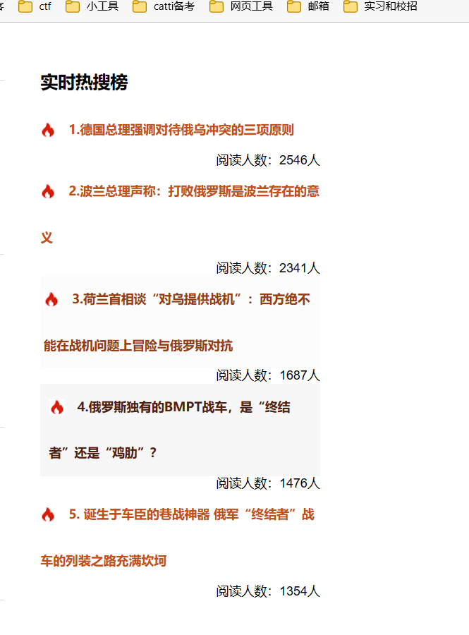

### 功能实现

1.实现新闻热度实时更新

2.展示新闻阅读人数

3.根据热度排序并连接新闻详情页面

### 代码展示

涉及表reader

视图层

<aside class="one_third last">  
 <ul class="widgets">  
 <li class="upcoming-widget">  
 <h4>实时热搜榜</h4>  
  
 <section class="container">  
 <ul class="slides">  
 <li><a href="./index.php?r=article/index1#"><span class="icon"><img src="./css/images/hot.png" alt="" /></span> <strong>1.<?php echo $bestArticle[0]['title'] ?></strong></a></li>  
 <span class="right">阅读人数：<?php echo $readNumber[0]['number']?>人</span><br>  
 <li><a href="./index.php?r=article/index7#"><span class="icon"><img src="./css/images/hot.png" alt="" /></span> <strong>2.<?php echo $bestArticle[1]['title'] ?></strong></a></li>  
 <span class="right">阅读人数：<?php echo $readNumber[1]['number']?>人</span><br>  
 <li><a href="./index.php?r=article/index12#"><span class="icon"><img src="./css/images/hot.png" alt="" /></span> <strong>3.<?php echo $bestArticle[2]['title'] ?></strong></a></li>  
 <span class="right">阅读人数：<?php echo $readNumber[2]['number']?>人</span><br>  
 <li><a href="./index.php?r=article/index15#"><span class="icon"><img src="./css/images/hot.png" alt="" /></span> <strong>4.<?php echo $bestArticle[3]['title'] ?></strong></a></li>  
 <span class="right">阅读人数：<?php echo $readNumber[3]['number']?>人</span><br>  
 <li><a href="./index.php?r=article/index17#"><span class="icon"><img src="./css/images/hot.png" alt="" /></span> <strong>5.<?php echo $bestArticle[4]['title'] ?></strong></a></li>  
 <span class="right">阅读人数：<?php echo $readNumber[4]['number']?>人</span><br>  
  
 </ul>  
 </section>  
 </li>  
  
 </ul>  
</aside>

模型层

<?php  
namespace app\models;  
  
use yii\db\ActiveRecord;  
  
class reader extends ActiveRecord  
{  
}

控制器层

$sql6="select title from reader order by number desc";  
$r6=reader::*findBysql*($sql6)->all();  
  
  
$sql7="select number from reader order by number desc";  
$r7=reader::*findBysql*($sql7)->all();  
  
$data=['title'=>$r1,  
 'abstract'=>$r2,  
 'authorName'=>$r3,  
 'doneDate'=>$r4,  
 'doneTime'=>$r5,  
 'bestArticle'=>$r6,  
 'readNumber'=>$r7,  
 ];  
  
return $this->renderPartial('index',$data);

## 新闻详情界面

### 页面展示



### 功能实现

涉及表news

1.实现新闻详情的报道

2.实现多篇新闻间的相互跳转

### 代码展示

视图层

<section class="top-image" style="background:url('css/images/1.jpg') no-repeat top center;">  
 <h1>俄乌战争最新局势报道</h1>  
</section>  
  
<section id="bottom">  
 <section class="shell">  
  
 <section id="content" class="two_third">  
  
 <h1> <?php echo $title[0]['title']; ?></h1>  
 <p> <?php echo $text[0]['text']; ?></p>  
  
 <div class="comments">  
  
 <h4>评论</h4>

模型层

<?php  
namespace app\models;  
  
use yii\db\ActiveRecord;  
  
class news extends ActiveRecord  
{  
}

控制器层

public function actionIndex0()  
{  
  
 $sql1="select title from news where id=0";  
 $r1=news::*findBysql*($sql1)->all();  
  
 $sql2="select text from news where id=0";  
 $r2=news::*findBysql*($sql2)->all();  
  
 $sql3="select name from review order by rand() limit 4";  
 $r3=review::*findBysql*($sql3)->all();  
  
  
 $sql4="select content from review order by rand() limit 4";  
 $r4=review::*findBysql*($sql4)->all();  
  
 $sql5="select time from review order by rand() limit 4";  
 $r5=review::*findBysql*($sql5)->all();  
  
 $sql6="select title from reader order by number desc";  
 $r6=reader::*findBysql*($sql6)->all();  
  
  
  
 $sql7="select number from reader order by number desc";  
 $r7=reader::*findBysql*($sql7)->all();  
  
 $data=['title'=>$r1,  
 'text'=>$r2,  
 'name'=>$r3,  
 'content'=>$r4,  
 'time'=>$r5,  
 'bestArticle'=>$r6,  
 'readNumber'=>$r7,  
 ];  
 return $this->renderPartial('index0',$data);  
}

## 评论界面

### 页面展示

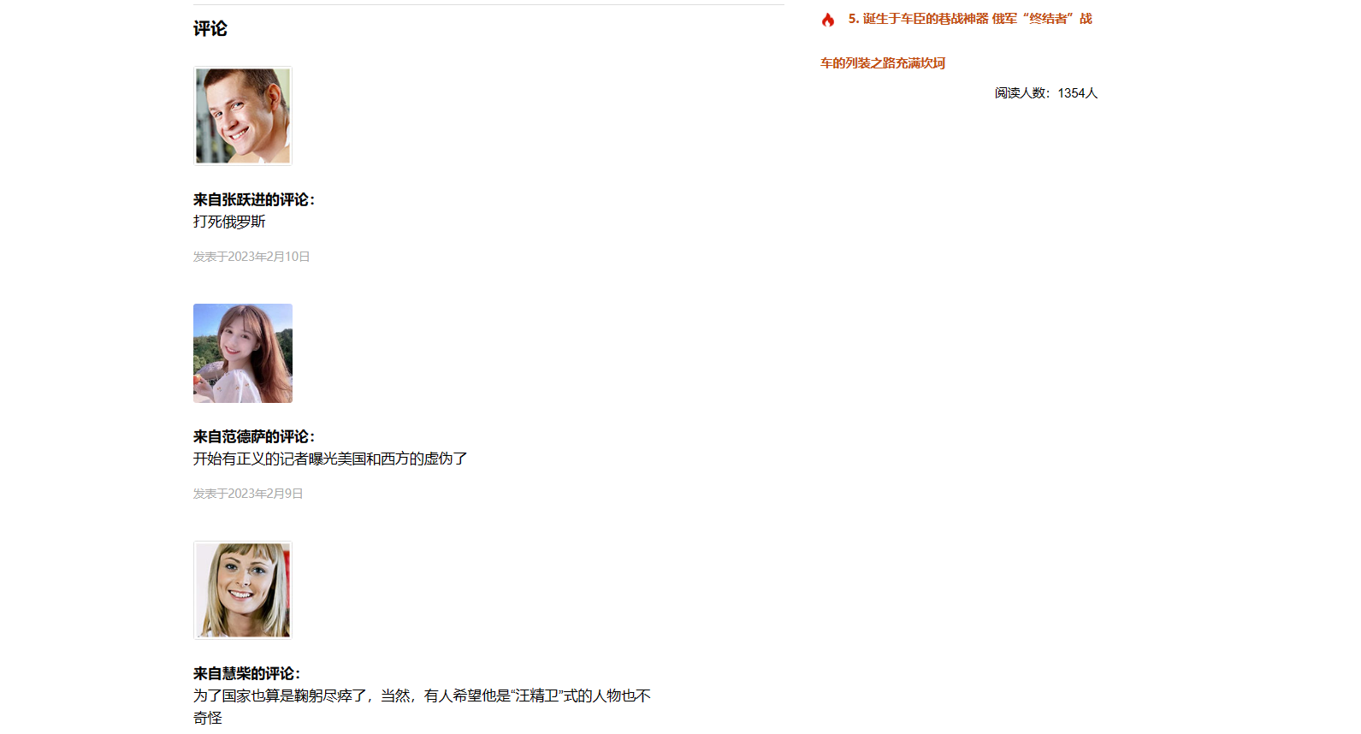

### 功能实现

1.实现用户信息的展示

2.实现用户评论内容的展示

3.根据评论时间排序展示评论

### 代码展示

视图层

<h4>评论</h4>  
  
<div class="one_fifth">  
 <img src="./css/images/trainer1.jpg" width="100%" />  
</div>  
  
<div class="four_fifth last">  
  
 <p><strong>来自<?php echo $name[0]['name']; ?>的评论：</strong><br />  
 <?php echo $content[0]['content']; ?>  
 </p>  
  
 <h6>发表于<?php echo $time[0]['time']; ?></h6>  
  
</div>  
  
<div class="cl"></div>  
  
<div class="one_fifth">  
 <img src="./css/images/trainer4.jpg" width="100%" />  
</div>  
  
<div class="four_fifth last">  
  
 <p><strong>来自<?php echo $name[1]['name']; ?>的评论：</strong><br />  
 <?php echo $content[1]['content']; ?>  
 </p>  
  
 <h6>发表于<?php echo $time[1]['time']; ?></h6>  
  
</div>  
  
<div class="cl"></div>  
  
<div class="one_fifth">  
 <img src="./css/images/trainer2.jpg" width="100%" />  
</div>  
  
<div class="four_fifth last">  
  
 <p><strong>来自<?php echo $name[2]['name']; ?>的评论：</strong><br />  
 <?php echo $content[2]['content']; ?>  
 </p>  
  
 <h6>发表于<?php echo $time[2]['time']; ?></h6>  
  
</div>  
  
<div class="cl"></div>  
  
<div class="one_fifth">  
 <img src="./css/images/trainer3.jpg" width="100%" />  
</div>  
  
<div class="four_fifth last">  
  
 <p><strong>来自<?php echo $name[3]['name']; ?>的评论：</strong><br />  
 <?php echo $content[3]['content']; ?>  
 </p>  
  
 <h6>发表于<?php echo $time[3]['time']; ?></h6>  
  
</div>  
  
<div class="cl"></div>

模型层

<?php  
namespace app\models;  
  
use yii\db\ActiveRecord;  
  
class review extends ActiveRecord  
{  
}

控制器层

$sql3="select name from review order by rand() limit 4";  
$r3=review::*findBysql*($sql3)->all();  
  
  
$sql4="select content from review order by rand() limit 4";  
$r4=review::*findBysql*($sql4)->all();

$data=['title'=>$r1,  
 'text'=>$r2,  
 'name'=>$r3,  
 'content'=>$r4,  
 'time'=>$r5,  
 'bestArticle'=>$r6,  
 'readNumber'=>$r7,  
];  
return $this->renderPartial('index0',$data);

# 实现文档@张继盛

Github提交记录

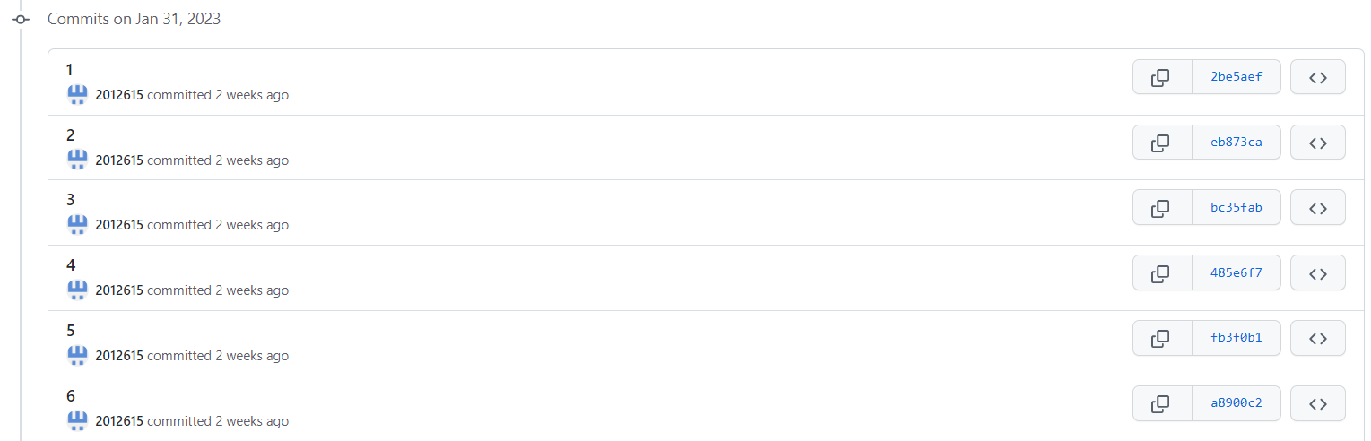

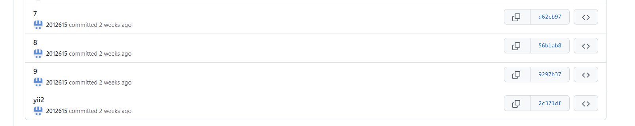

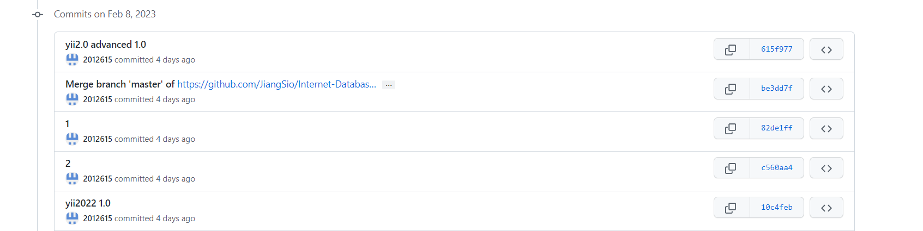

项目细节

俄乌历史矛盾@张继盛

主界面

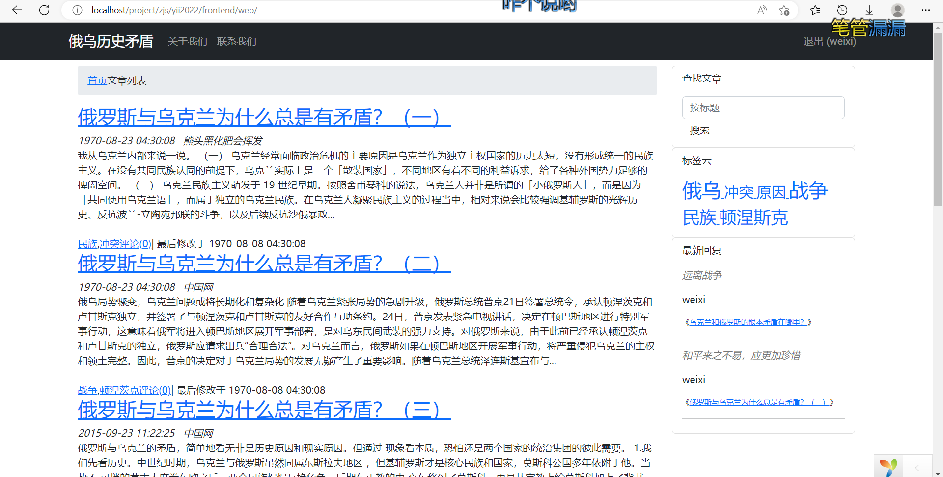

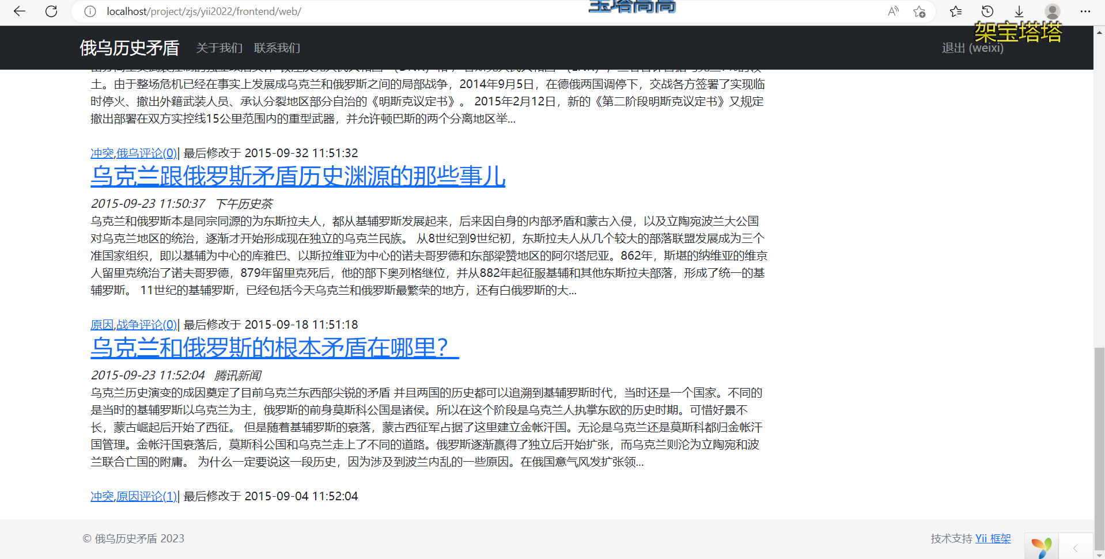

搜索功能

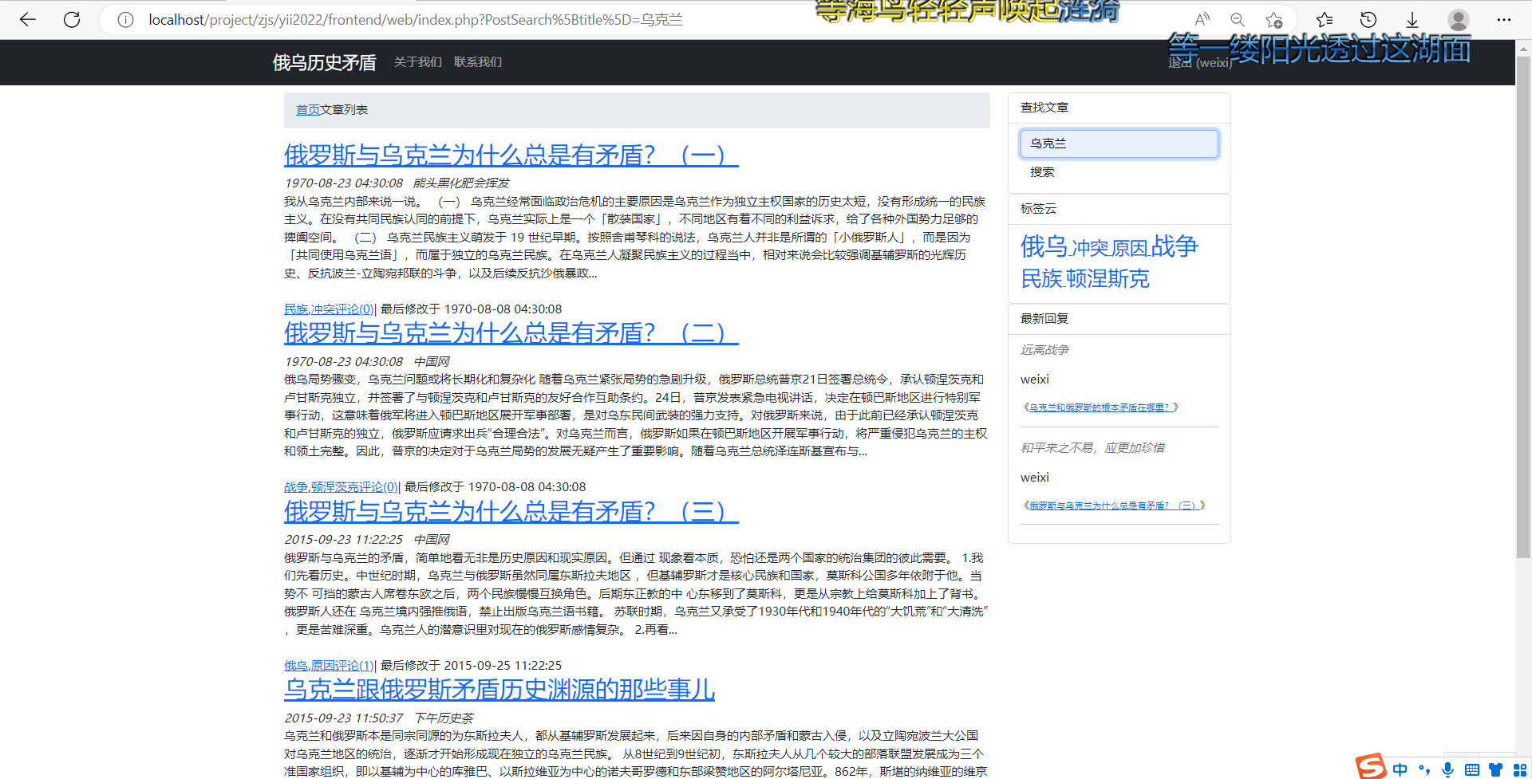

标签搜索

点击标签，可显示所有带有该标签的文章

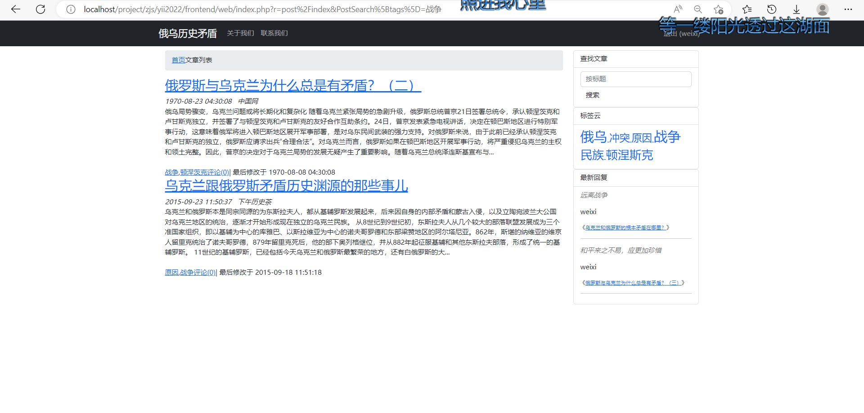

文章详情

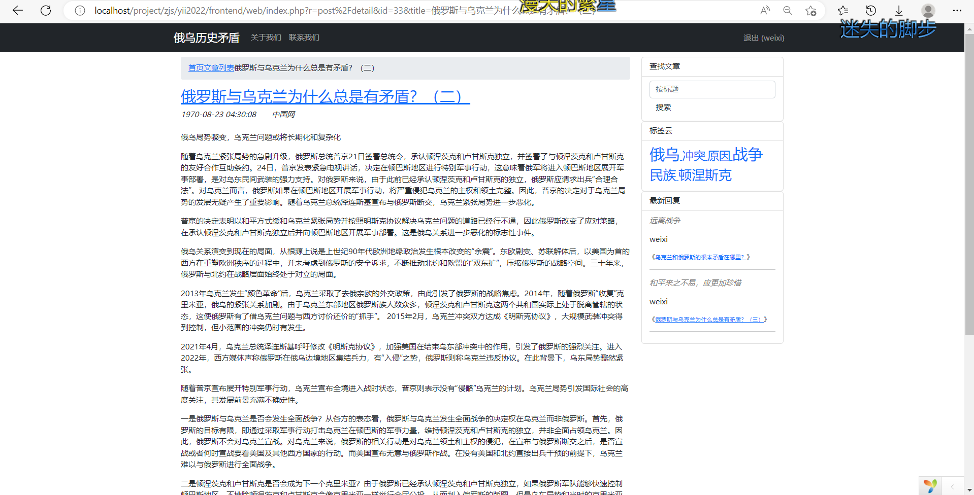

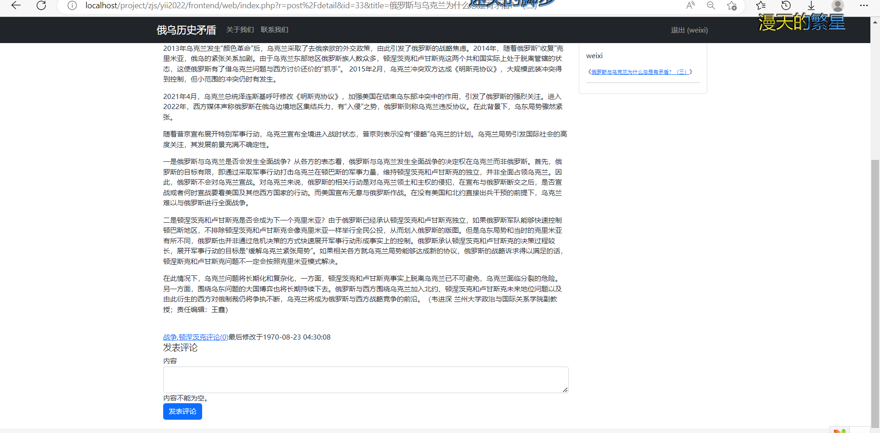

可发表评论，提交后经后台审核通过可展示

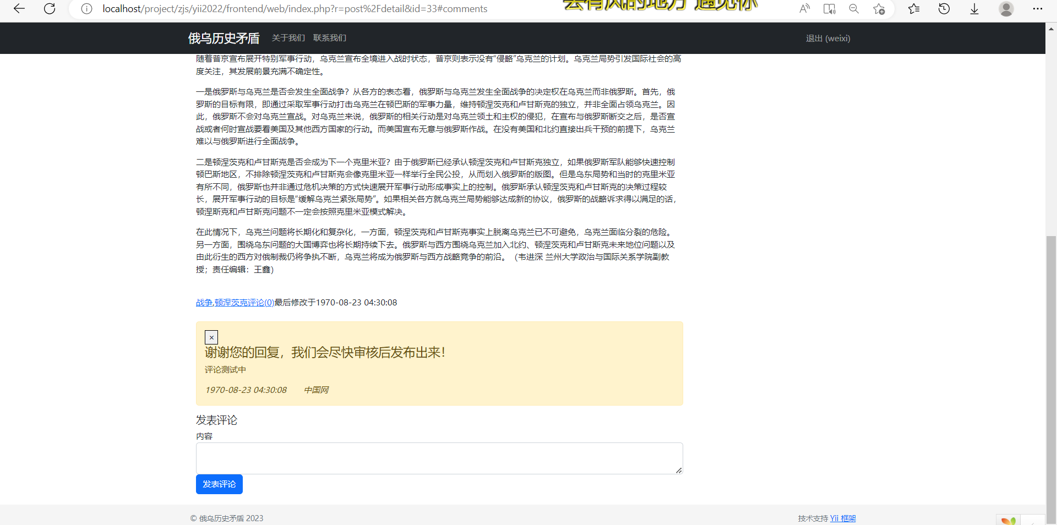

代码实现

Index.php

<?php

use yii\widgets\ListView;

use yii\data\ActiveDataProvider;

use common\models\Post;

use yii\helpers\Html;

use yii\helpers\Url;

use yii\grid\ActionColumn;

use yii\grid\GridView;

use frontend\components\TagsCloudWidget;

use frontend\components\RctReplyWidget;

/** @var yii\web\View $this */

/** @var common\models\PostSearch $searchModel */

/** @var yii\data\ActiveDataProvider $dataProvider */

?>

<div class="container">

    <div class="row">

        <div class="col-md-9">

            <ol class="breadcrumb">

            <li><a href="<?= Yii::$app->homeUrl;?>">首页</a></li>

            <li>文章列表</li>

            </ol>

            <?=ListView::widget([

                'id'=>'postlist',

                'dataProvider'=>$dataProvider,

                'itemView'=>'_listitem',

                'layout'=>'{items} {pager}',

                'pager'=>[

                'maxButtonCount'=>10,

                'nextPageLabel'=>Yii::t('app','下一页'),

                'prevPageLabel'=>Yii::t('app','上一页'),

                ],

                ])?>

        </div>

        <div class="col-md-3">

            <div class="searchbox">

                <ul class="list-group">

                    <li class="list-group-item">

                    <span class="glyphiconglyphicon-search"aria-hidden="true"></span>查找文章

                    </li>

                    <li class="list-group-item">

                        <form class="form-inline" action="index.php?r=post/index" id="w0" method="get">

                            <div class="form-group">

                                <input type="text" class="form-control" name="PostSearch[title]" id="w0input" placeholder="按标题">

                            </div>

                            <button type="submit" class="btn btn-default">搜索</button>

                        </form>

                    </li>

                </ul>

            </div>

            <div class="tagcloudbox">

                <ul class="list-group">

                    <li class="list-group-item">

                    <span class="glyphiconglyphicon-search"aria-hidden="true"></span>标签云

                    </li>

                    <li class="list-group-item">

                        <?= TagsCloudWidget::widget(['tags'=>$tags])?>

                    </li>

                </ul>

            </div>

            <div class="commentbox">

                <ul class="list-group">

                    <li class="list-group-item">

                    <span class="glyphiconglyphicon-search"aria-hidden="true"></span>最新回复

                    </li>

                    <li class="list-group-item">

                        <?= RctReplyWidget::widget(['recentComments'=>$recentComments])?>

                    </li>

                </ul>

            </div>

        </div>

    </div>

</div>

Post.php

<?php

namespace common\models;

use Yii;

use yii\helpers\Html;

/**

 * This is the model class for table "post".

 *

 * @property int $id

 * @property string $title

 * @property string $content

 * @property string|null $tags

 * @property int $status

 * @property int|null $create_time

 * @property int|null $update_time

 * @property int $author_id

 *

 * @property Adminuser $author

 * @property Comment[] $comments

 * @property Poststatus $status0

 */

class Post extends \yii\db\ActiveRecord

{

    private $_oldTags;

    /**

     * {@inheritdoc}

     */

    public static function tableName()

    {

        return 'post';

    }

    /**

     * {@inheritdoc}

     */

    public function rules()

    {

        return [

            [['title', 'content', 'status', 'author_id'], 'required'],

            [['content', 'tags'], 'string'],

            [['status', 'create_time', 'update_time', 'author_id'], 'integer'],

            [['title'], 'string', 'max' => 128],

            [['author_id'], 'exist', 'skipOnError' => true, 'targetClass' => Adminuser::class, 'targetAttribute' => ['author_id' => 'id']],

            [['status'], 'exist', 'skipOnError' => true, 'targetClass' => Poststatus::class, 'targetAttribute' => ['status' => 'id']],

        ];

    }

    /**

     * {@inheritdoc}

     */

    public function attributeLabels()

    {

        return [

            'id' => 'ID',

            'title' => '标题',

            'content' => '内容',

            'tags' => '标签',

            'status' => '状态',

            'create_time' => '创建时间',

            'update_time' => '修改时间',

            'author_id' => '作者',

        ];

    }

    /**

     * Gets query for [[Author]].

     *

     * @return \yii\db\ActiveQuery

     */

    public function getAuthor()

    {

        return $this->hasOne(Adminuser::class, ['id' => 'author_id']);

    }

    /**

     * Gets query for [[Comments]].

     *

     * @return \yii\db\ActiveQuery

     */

    public function getComments()

    {

        return $this->hasMany(Comment::class, ['post_id' => 'id']);

    }

    public function getActiveComments()

    {

        return $this->hasMany(Comment::class, ['post_id' => 'id'])->where('status=:status',[':status'=>2])->orderBy('id DESC');

    }

    /**

     * Gets query for [[Status0]].

     *

     * @return \yii\db\ActiveQuery

     */

    public function getStatus0()

    {

        return $this->hasOne(Poststatus::class, ['id' => 'status']);

    }

    public function beforeSave($insert)

    {

        if(parent::beforeSave($insert))

        {

            if($insert)

            {

                $this->create_time=time();

                $this->update_time=time();

            }

            else

            {

                $this->update_time=time();

            }

            return true;

        }

        else

        {

            return false;

        }

    }

    public function afterFind()

    {

        parent::afterFind();

        $this->_oldTags = $this->tags;

    }

    public function afterSave($insert, $changedAttributes)

    {

        parent::afterSave($insert,$changedAttributes);

        Tag::updateFrequency($this->_oldTags,$this->tags);

    }

    public function afterDelete()

    {

        parent::afterDelete();

        Tag::updateFrequency($this->tags,'');

    }

    public function getUrl()

    {

        return Yii::$app->urlManager->createUrl(

            ['post/detail','id'=>$this->id,'title'=>$this->title]);

    }

    public function getBeginning($length=288)

    {

        $tmpStr=strip_tags($this->content);

        $tmpLen=mb_strlen($tmpStr);

        $tmpStr = mb_substr($tmpStr,0,$length,'utf-8');

        return $tmpStr.($tmpLen>$length?'...':'');

    }

    public function getTagLinks()

    {

        $links=array();

        foreach(Tag::string2array($this->tags)as $tag)

        {

            $links[]=Html::a(Html::encode($tag),array('post/index','PostSearch[tags]'=>$tag));

        }

        return $links;

    }

    public function getCommentCount()

    {

        return Comment::find()->where(['post_id'=>$this->id,'status'=>2])->count();

    }

}

Tag.php

<?php

namespace common\models;

use Yii;

use yii\base\Model;

/**

 * This is the model class for table "tag".

 *

 * @property int $id

 * @property string $name

 * @property int|null $frequency

 */

class Tag extends \yii\db\ActiveRecord

{

    /**

     * {@inheritdoc}

     */

    public static function tableName()

    {

        return 'tag';

    }

    /**

     * {@inheritdoc}

     */

    public function rules()

    {

        return [

            [['name'], 'required'],

            [['frequency'], 'integer'],

            [['name'], 'string', 'max' => 128],

        ];

    }

    /**

     * {@inheritdoc}

     */

    public function attributeLabels()

    {

        return [

            'id' => 'ID',

            'name' => 'Name',

            'frequency' => 'Frequency',

        ];

    }

    public static function string2array($tags)

    {

        return preg_split('/\s*,\s*/',trim($tags),-1,PREG_SPLIT_NO_EMPTY);

    }

    public static function array2string($tags)

    {

        return implode(',',$tags);

    }

    public static function addTags($tags)

    {

        if(empty($tags)) return ;

        foreach ($tags as $name)

        {

            $aTag = Tag::find()->where(['name'=>$name])->one();

            $aTagCount=Tag::find()->where(['name'=>$name])->count();

            if(!$aTagCount)

            {

                $tag = new Tag;

                $tag->name= $name;

                $tag->frequency=1;

                $tag->save();

            }

            else

            {

                $aTag->frequency += 1;

                $aTag->save();

            }

        }

    }

    public static function removeTags($tags)

    {

        if(empty($tags))return ;

        foreach($tags as $name)

        {

            $aTag = Tag::find()->where(['name'=>$name])->one();

            $aTagCount=Tag::find()->where(['name'=>$name])->count();

            if($aTagCount)

            {

                if($aTagCount && $aTag->frequency<=1)

                {

                    $aTag->delete();

                }

                else

                {

                    $aTag->frequency -= 1;

                    $aTag->save();

                }

            }

        }

    }

    public static function updateFrequency($oldTags,$newTags)

    {

        if(!empty($oldTags)||!empty($newTags))

        {

            $oldTagsArray= self::string2array($oldTags);

            $newTagsArray= self::string2array($newTags);

            self::addTags(array_values(array_diff($newTagsArray,$oldTagsArray)));

            self::removeTags(array_values(array_diff($oldTagsArray,$newTagsArray)));

        }

    }

    public static function findTagWeights($limit=20)

    {

        $tag_size_level = 5;

        $models=Tag::find()->orderBy('frequency desc')->limit($limit)->all();

        $total=Tag::find()->limit($limit)->count();

        $stepper=ceil($total/$tag_size_level);

        $tags=array();

        $counter=1;

        if($total>0)

        {

            foreach ($models as $model)

            {

                $weight=ceil($counter/$stepper)+1;

                $tags[$model->name]=$weight;

                $counter++;

            }

            ksort($tags);

        }

        return $tags;

    }

}

PostController.php

<?php

namespace frontend\controllers;

use Yii;

use common\models\Post;

use common\models\PostSearch;

use yii\web\Controller;

use yii\web\NotFoundHttpException;

use yii\filters\VerbFilter;

use yii\filters\AccessControl;

use common\models\Tag;

use common\models\Comment;

use common\models\User;

use yii\rest\Serializer;

/**

 * PostController implements the CRUD actions for Post model.

 */

class PostController extends Controller

{

    public $added=0; //0代表还没有新回复

    /**

     * @inheritdoc

     */

    public function behaviors()

    {

        return [

            'verbs' => [

                'class' => VerbFilter::className(),

                'actions' => [

                    'delete' => ['POST'],

                ],

            ],

                'access' =>[

                        'class' => AccessControl::className(),

                        'rules' =>

                        [

                                [

                                        'actions' => ['index'],

                                        'allow' => true,

                                        'roles' => ['?'],

                                        ],

                                        [

                                                'actions' => ['index', 'detail'],

                                                'allow' => true,

                                                'roles' => ['@'],

                                ],

                                ],

                                ],

            'pageCache'=>[

                    'class'=>'yii\filters\PageCache',

                    'only'=>['index'],

                    'duration'=>600,

                    'variations'=>[

                            Yii::$app->request->get('page'),

                            Yii::$app->request->get('PostSearch'),

                    ],

                    'dependency'=>[

                            'class'=>'yii\caching\DbDependency',

                            'sql'=>'select count(id) from post',

                    ],

            ],

            'httpCache'=>[

                    'class'=>'yii\filters\HttpCache',

                    'only'=>['detail'],

                    'lastModified'=>function ($action,$params){

                        $q = new \yii\db\Query();

                        return $q->from('post')->max('update_time');

                    },

                    'etagSeed'=>function ($action,$params) {

                        $post = $this->findModel(Yii::$app->request->get('id'));

                        return serialize([$post->title,$post->content]);

                    },

                    'cacheControlHeader' => 'public,max-age=600',

            ],

        ];

    }

    /**

     * Lists all Post models.

     * @return mixed

     */

    public function actionIndex()

    {

        $tags=Tag::findTagWeights();

        $recentComments=Comment::findRecentComments();

        $searchModel = new PostSearch();

        $dataProvider = $searchModel->search(Yii::$app->request->queryParams);

        return $this->render('index', [

            'searchModel' => $searchModel,

            'dataProvider' => $dataProvider,

            'tags'=>$tags,

            'recentComments'=>$recentComments,

        ]);

    }

    /**

     * Displays a single Post model.

     * @param integer $id

     * @return mixed

     */

    public function actionView($id)

    {

        return $this->render('view', [

            'model' => $this->findModel($id),

        ]);

    }

    /**

     * Creates a new Post model.

     * If creation is successful, the browser will be redirected to the 'view' page.

     * @return mixed

     */

    public function actionCreate()

    {

        $model = new Post();

        if ($model->load(Yii::$app->request->post()) && $model->save()) {

            return $this->redirect(['view', 'id' => $model->id]);

        } else {

            return $this->render('create', [

                'model' => $model,

            ]);

        }

    }

    /**

     * Updates an existing Post model.

     * If update is successful, the browser will be redirected to the 'view' page.

     * @param integer $id

     * @return mixed

     */

    public function actionUpdate($id)

    {

        $model = $this->findModel($id);

        if ($model->load(Yii::$app->request->post()) && $model->save()) {

            return $this->redirect(['view', 'id' => $model->id]);

        } else {

            return $this->render('update', [

                'model' => $model,

            ]);

        }

    }

    /**

     * Deletes an existing Post model.

     * If deletion is successful, the browser will be redirected to the 'index' page.

     * @param integer $id

     * @return mixed

     */

    public function actionDelete($id)

    {

        $this->findModel($id)->delete();

        return $this->redirect(['index']);

    }

    /**

     * Finds the Post model based on its primary key value.

     * If the model is not found, a 404 HTTP exception will be thrown.

     * @param integer $id

     * @return Post the loaded model

     * @throws NotFoundHttpException if the model cannot be found

     */

    protected function findModel($id)

    {

        if (($model = Post::findOne($id)) !== null) {

            return $model;

        } else {

            throw new NotFoundHttpException('The requested page does not exist.');

        }

    }

    public function actionDetail($id)

    {

        //step1. 准备数据模型

        $model = $this->findModel($id);

        $tags=Tag::findTagWeights();

        $recentComments=Comment::findRecentComments();

        $userMe = User::findOne(Yii::$app->user->id);

        $commentModel = new Comment();

        $commentModel->email = $userMe->email;

        $commentModel->userid = $userMe->id;

        //step2. 当评论提交时，处理评论

        if($commentModel->load(Yii::$app->request->post()))

        {

            $commentModel->status = 1; //新评论默认状态为 pending

            $commentModel->post_id = $id;

            if($commentModel->save())

            {

                $this->added=1;

            }

        }

        //step3.传数据给视图渲染

        return $this->render('detail',[

                'model'=>$model,

                'tags'=>$tags,

                'recentComments'=>$recentComments,

                'commentModel'=>$commentModel,

                'added'=>$this->added,

        ]);

    }

}

Detail.php

<?php

use yii\helpers\Html;

use yii\grid\GridView;

use yii\widgets\ListView;

use frontend\components\TagsCloudWidget;

use frontend\components\RctReplyWidget;

use yii\helpers\HtmlPurifier;

use common\models\Comment;

use yii\helpers\Url;

/* @var $this yii\web\View */

/* @var $searchModel common\models\PostSearch */

/* @var $dataProvider yii\data\ActiveDataProvider */

?>

<div class="container">

    <div class="row">

        <div class="col-md-9">

            <ol class="breadcrumb">

            <li><a href="<?= Yii::$app->homeUrl;?>">首页</a></li>

            <li><a href="<?= Url::to(['post/index']);?>">文章列表</a></li>

            <li class="active"><?= $model->title?></li>

            </ol>

            <div class="post">

                <div class="title">

                    <h2><a href="<?= $model->url;?>"><?= Html::encode($model->title);?></a></h2>

                        <div class="author">

                        <span class="glyphicon glyphicon-time" aria-hidden="true"></span><em><?= date('Y-m-d H:i:s',$model->create_time)."&nbsp;&nbsp;&nbsp;&nbsp;&nbsp;&nbsp;";?></em>

                        <span class="glyphicon glyphicon-user" aria-hidden="true"></span><em><?= Html::encode($model->author->nickname);?></em>

                        </div>

                </div>

            <br>

            <div class="content">

            <?= HTMLPurifier::process($model->content)?>

            </div>

            <br>

            <div class="nav">

                <span class="glyphicon glyphicon-tag" aria-hidden="true"></span>

                <?= implode(', ',$model->tagLinks);?>

                <br>

                <?= Html::a("评论({$model->commentCount})",$model->url.'#comments');?>

                最后修改于<?= date('Y-m-d H:i:s',$model->update_time);?>

            </div>

        </div>

        <div id="comments">

            <?php if($added) {?>

            <br>

            <div class="alert alert-warning alert-dismissible" role="alert">

              <button type="button" class="close" data-dismiss="alert" aria-label="Close"><span aria-hidden="true">&times;</span></button>

              <h4>谢谢您的回复，我们会尽快审核后发布出来！</h4>

              <p><?= nl2br($commentModel->content);?></p>

                <span class="glyphicon glyphicon-time" aria-hidden="true"></span><em><?= date('Y-m-d H:i:s',$model->create_time)."&nbsp;&nbsp;&nbsp;&nbsp;&nbsp;&nbsp;";?></em>

                <span class="glyphicon glyphicon-user" aria-hidden="true"></span><em><?= Html::encode($model->author->nickname);?></em>

            </div>

            <?php }?>

            <?php if($model->commentCount>=1) :?>

            <h5><?= $model->commentCount.'条评论';?></h5>

            <?= $this->render('_comment',array(

                    'post'=>$model,

                    'comments'=>$model->activeComments,

            ));?>

            <?php endif;?>

            <h5>发表评论</h5>

            <?php

            $commentModel =new Comment();

            echo $this->render('_guestform',array(

                    'id'=>$model->id,

                    'commentModel'=>$commentModel,

            ));?>

            </div>

        </div>

        <div class="col-md-3">

            <div class="searchbox">

                <ul class="list-group">

                  <li class="list-group-item">

                  <span class="glyphicon glyphicon-search" aria-hidden="true"></span> 查找文章

                  </li>

                  <li class="list-group-item">

                      <form class="form-inline" action="index.php?r=post/index" id="w0" method="get">

                          <div class="form-group">

                            <input type="text" class="form-control" name="PostSearch[title]" id="w0input" placeholder="按标题">

                          </div>

                          <button type="submit" class="btn btn-default">搜索</button>

                    </form>

                  </li>

                </ul>

            </div>

            <div class="tagcloudbox">

                <ul class="list-group">

                  <li class="list-group-item">

                  <span class="glyphicon glyphicon-tags" aria-hidden="true"></span> 标签云

                  </li>

                  <li class="list-group-item">

                  <?= TagsCloudWidget::widget(['tags'=>$tags])?>

                   </li>

                </ul>

            </div>

            <div class="commentbox">

                <ul class="list-group">

                  <li class="list-group-item">

                  <span class="glyphicon glyphicon-comment" aria-hidden="true"></span> 最新回复

                  </li>

                  <li class="list-group-item">

                  <?= RctReplyWidget::widget(['recentComments'=>$recentComments])?>

                  </li>

                </ul>

            </div>

        </div>

    </div>

</div>

# 实现文档@姜天嘉

## 模板设计

前台设计采用的模板为Mate前台模板

后台设计采用的模板为AdminLTE后台模板

数据分析界面采用的大数据模板

## 界面展示

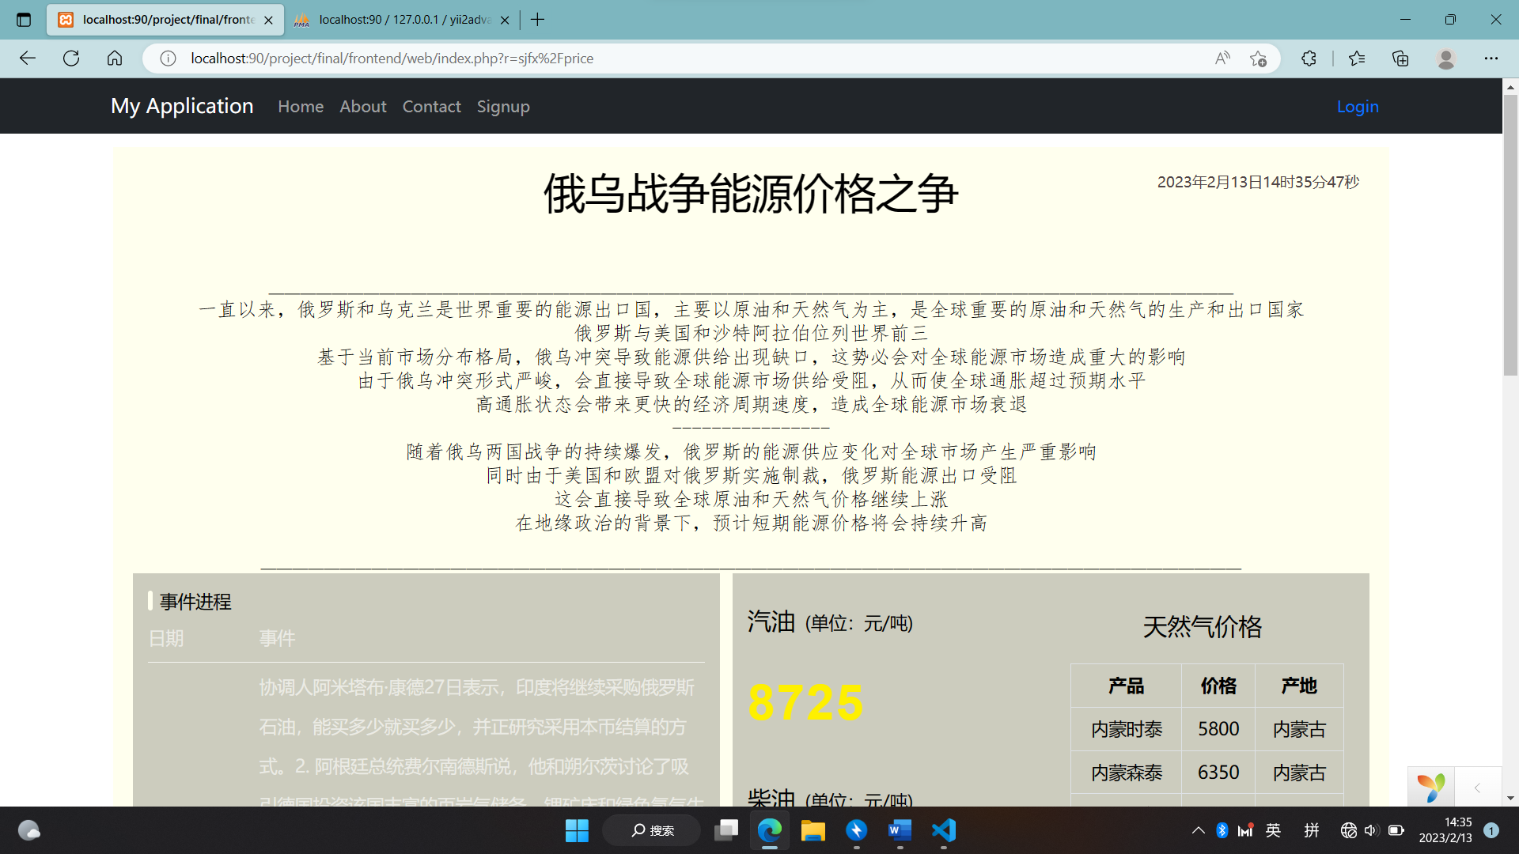

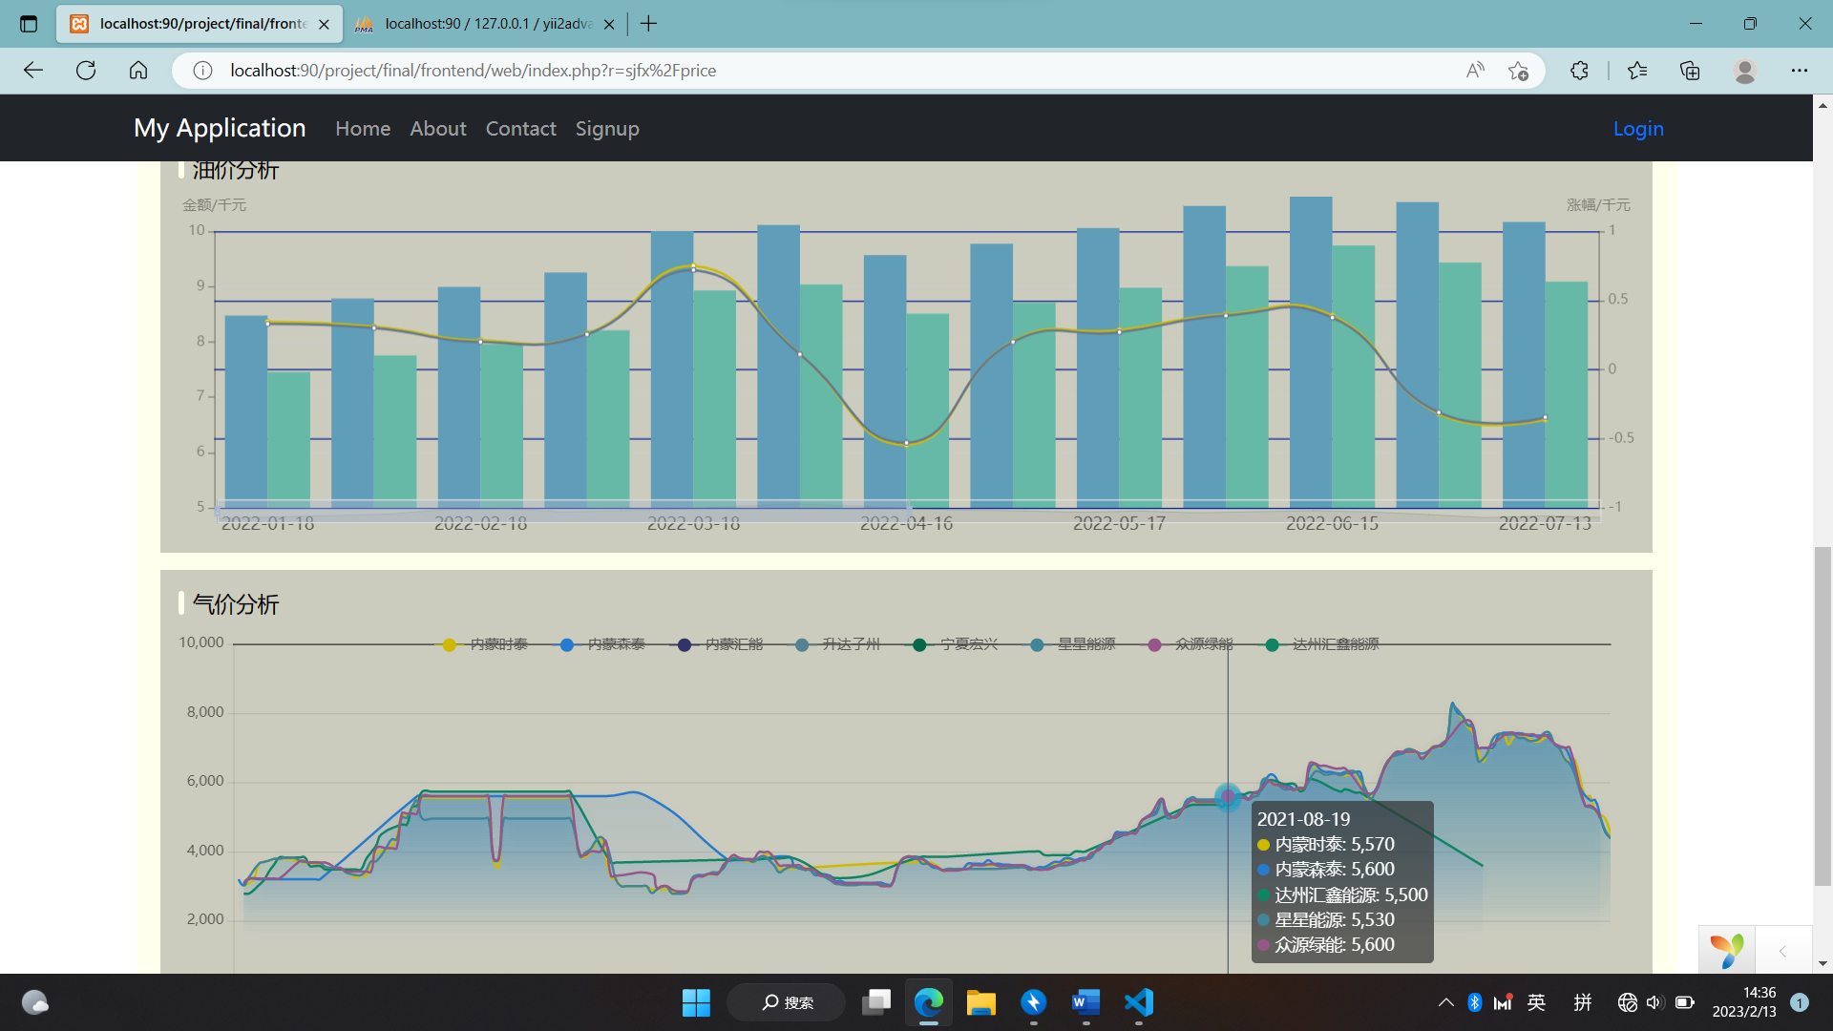 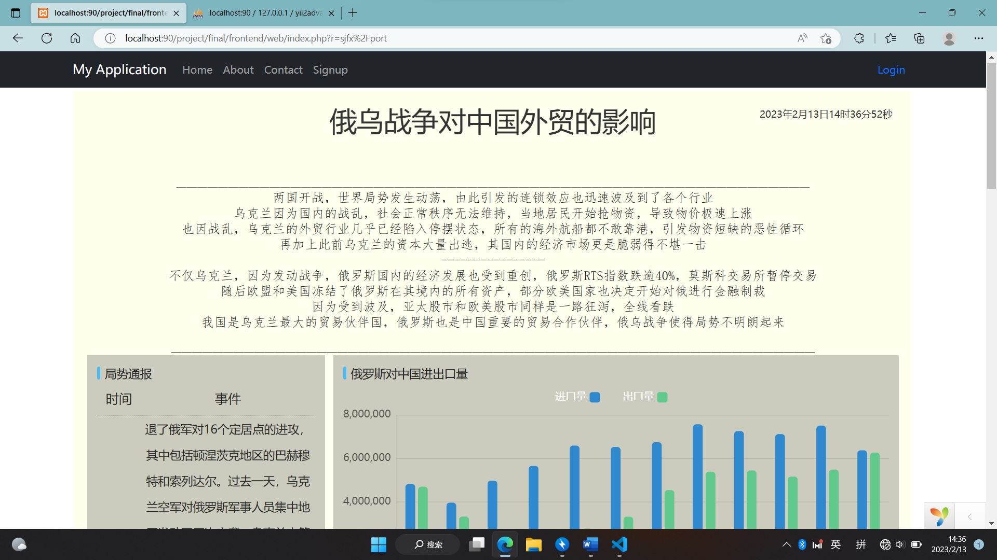

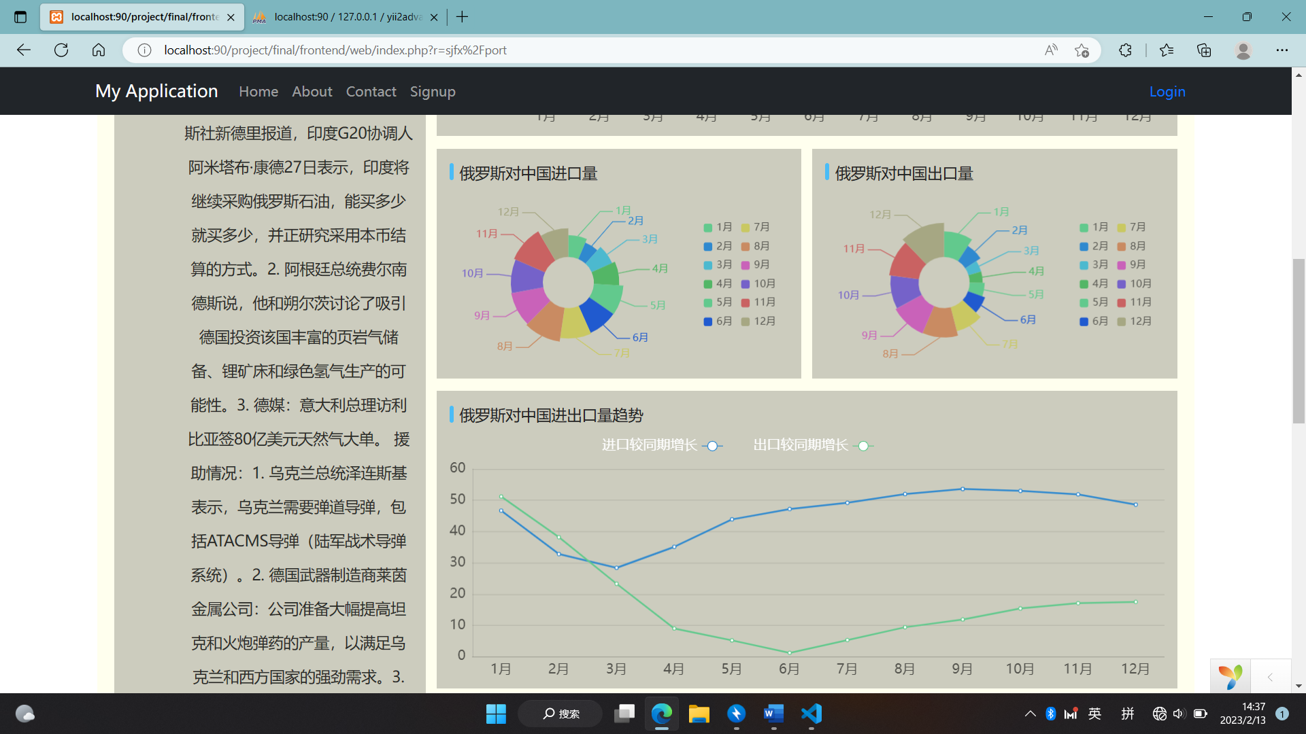

## 功能设计

登录功能

在yii2框架特有的登录功能上进行改进，增加了admin项用户判断用户是否为管理员用户，并且在管理员用户登录状态下显示后台入口

<li class="nav-item">

                <?php

                if(!*Yii*::$app->user->isGuest)

                {

                  $user=*User*::find()->where(['username'=>*Yii*::$app->user->identity->username])->one();

                  if($user->admin==1)

                  {

                    echo '<a class="nav-link page-scroll" href="/project/jtj/yii2022/backend/web/index.php">Backend</a>';

                  }

                }

                ?>

              </li>

倒计时模块

首页中有计算战争持续时间模块，利用异步模式触发页面变化

<script>

*var* t = setTimeout(time, 0); /*開始运行*/

*function* time(){

              clearTimeout(t); /*清除定时器*/

*var* date_start = new Date(2022,1,24).getTime();

*var* date_now = new Date().getTime();

*var* long = Math.floor((date_now-date_start)/1000);

*var* day=Math.floor(long/86400);

*var* hour=Math.floor((long%86400)/3600);

*var* minuet=Math.floor((long%3600)/60);

*var* second=(long%60);

              document.getElementById("day").innerHTML =day;

              document.getElementById("hour").innerHTML =hour;

              document.getElementById("minuet").innerHTML =minuet;

              document.getElementById("second").innerHTML =second;

              t = setTimeout(time, 1000);

            }

          </script>

数据分析模块

爬取数据

利用爬虫直接从一些网站上爬取数据（官方网站或者一些数据整理的网站）

将数据库的数据读取

use frontend\models*SjfxImportexport*;

$query=*SjfxImportexport*::find();

$datas=$query->orderBy('month')->all();

将数据映射到网页上

data:[

                                <?php

                                $str = '';

                                foreach($datas as $data){

                                    if($data->country=="俄罗斯联邦"){

                                        $str = $str.'{value:'.$data->in_m.",name:\"".$data->month."月\"},";

                                    }

                                }

                                echo $str;

                                ?>

                            ]

大致来说网页都是用这种方式实现的数据库访问

给过长数据表添加可伸缩横向拉伸条，在表的option中添加

dataZoom : [

                {

                  type: 'slider',

                  show: true,

                  height:20,

                  start: 0,

                  end: 50,

                  xAxisIndex: [0],

                },

              ],

直接利用echat中的库实现

实现数据库的提交

在后台界面有时候需要进行数据库信息的提交，这里采用一种javascript直接提交+php链接解析方式实现

<div class="card-body">

<form action="index.php" method="get" id="jtjclick">

    <div class="input-group mb-3">

        <div class="input-group-prepend">

        <span class="input-group-text"><i class="fas fa-envelope"></i></span>

        <span class="input-group-text">@姜天嘉</span>

        </div>

        <input type="text" class="form-control" id="jtj" name="jtj">

        <span class="input-group-append">

        <button type="button" class="btn btn-info btn-flat" onclick='document.getElementById("jtjclick").submit();'>Go!</button>

        </span>

    </div>

</form>

在控制器中实现数据提交至数据库并刷新

public *function* actionIndex()

    {

        $request = *Yii*::$app->request;

        $get1 = $request->get("jtj");

        if($get1!=null){

            $record=*Developer*::find()->where(['name'=>'姜天嘉'])->one();

            $record->text=$get1;

            $record->save();

            $this->redirect(array('site/index'));

        }

        $get2 = $request->get("yzh");

        if($get2!=null){

            $record=*Developer*::find()->where(['name'=>'闫钊辉'])->one();

            $record->text=$get2;

            $record->save();

            $this->redirect(array('site/index'));

        }

        $get3 = $request->get("wtp");

        if($get3!=null){

            $record=*Developer*::find()->where(['name'=>'王天鹏'])->one();

            $record->text=$get3;

            $record->save();

            $this->redirect(array('site/index'));

        }

        $get4 = $request->get("zjs");

        if($get4!=null){

            $record=*Developer*::find()->where(['name'=>'张继盛'])->one();

            $record->text=$get4;

            $record->save();

            $this->redirect(array('site/index'));

        }

        return $this->render('index');

    }

# 实现文档@闫钊辉

## 数据库实现

数据库的实现根据localhost进入数据库，数据库就是我们所设计的三个数据库，详见设计文档。

其中的数据来自网页中的自己寻找，数据详实

## 网页的设计

网页的设计首先要根据自己的选择的模板进行设计，下面是我选择的模板：

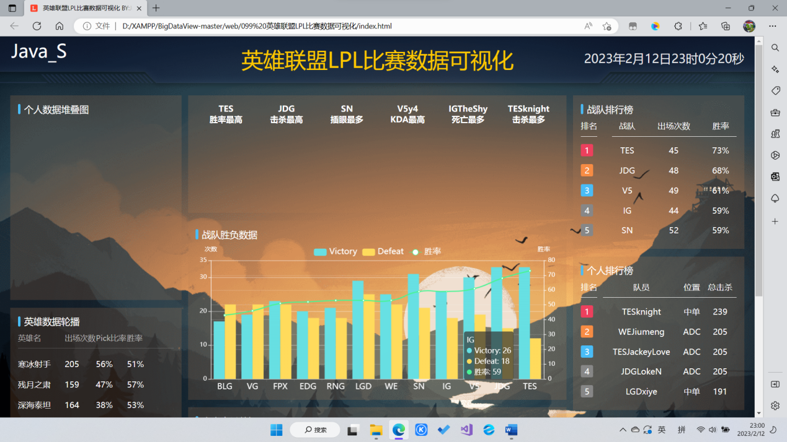

根据我自己的设计改良

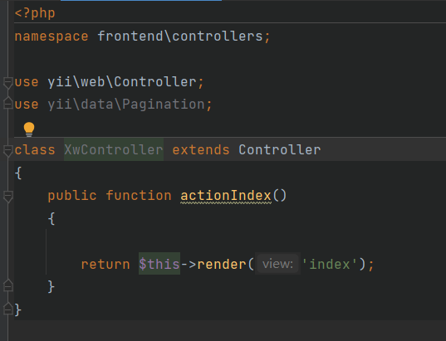

先实现一个控制器

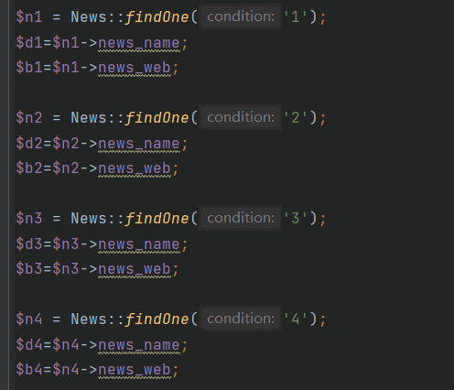

实现一下寻找数据库里面的数据

之后就是根据网页来进行修改。

